HOMEWORK 5
Kelly “Scott” Sims

Q1.2b
Trainable Parameters

- Layer 1 – Input Layer
  - 178 Inputs | No Trainable weights
- Layer 2 – Hidden Layer
  - 16 Neurons | 178 Weights per Neuron | 16 Bias Terms
- Layer 3 – Output Layer
  - 5 Neurons | 16 Weights per Neuron | 5 Bias Terms

Layer 2 = (16 * 178) + 16 = 2864
Layer 3 = (5 * 16 ) + 5 = 85

Total Trainable parameters = 2949

FLOPs
When a new observation is fed forward through the model, each feature is multiplied by a subsequent weight in the first hidden layer

Since there are 178 input features, there are 178 weights, that’s 178 multiplication operations for a single neuron. The product of those ops are then summed together with a subsequent bias term

That’s 178 addition ops. That output of that is then fed into a sigmoid activation function

Where there is an exponential op, addition op, and division op => 3 FLOPs for the activation function. The same logic applies for the output layer except no activation function

Hidden layer
16 neurons * (178 weight multiplication + 178 addition ops + 3 ops in activation function) = 5744
Output layer
5 neurons * (16 weight multiplication + 16 addition ops) = 160

Total FLOPs for One Observation = 5904

Q1.2c
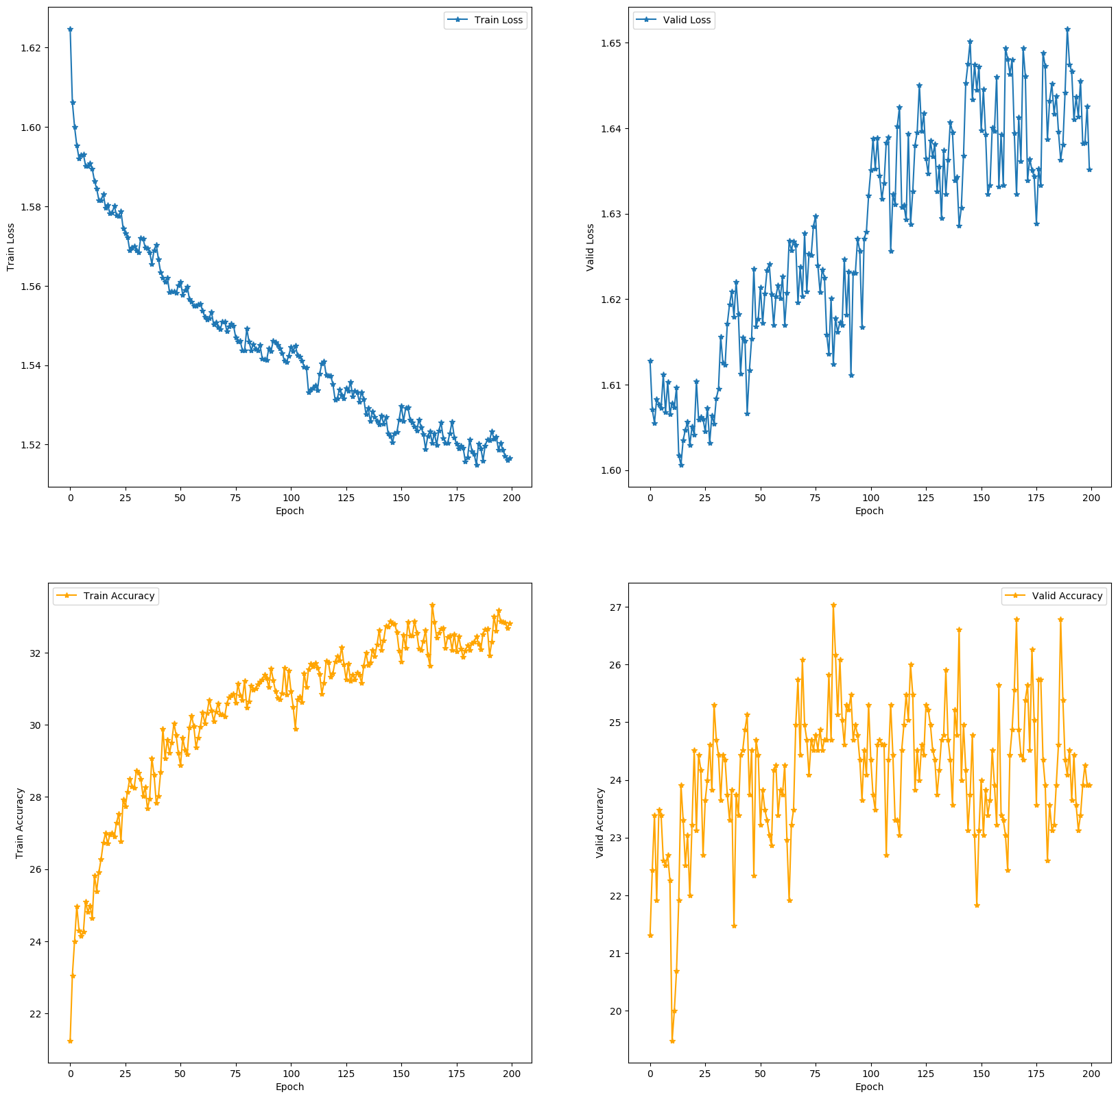Illustration 1: (Upper Left) Training Loss; (Upper Right) Validation Loss; (Lower Left) Training Accuracy; (Lower Right) Validation Accuracy

Q1.2d
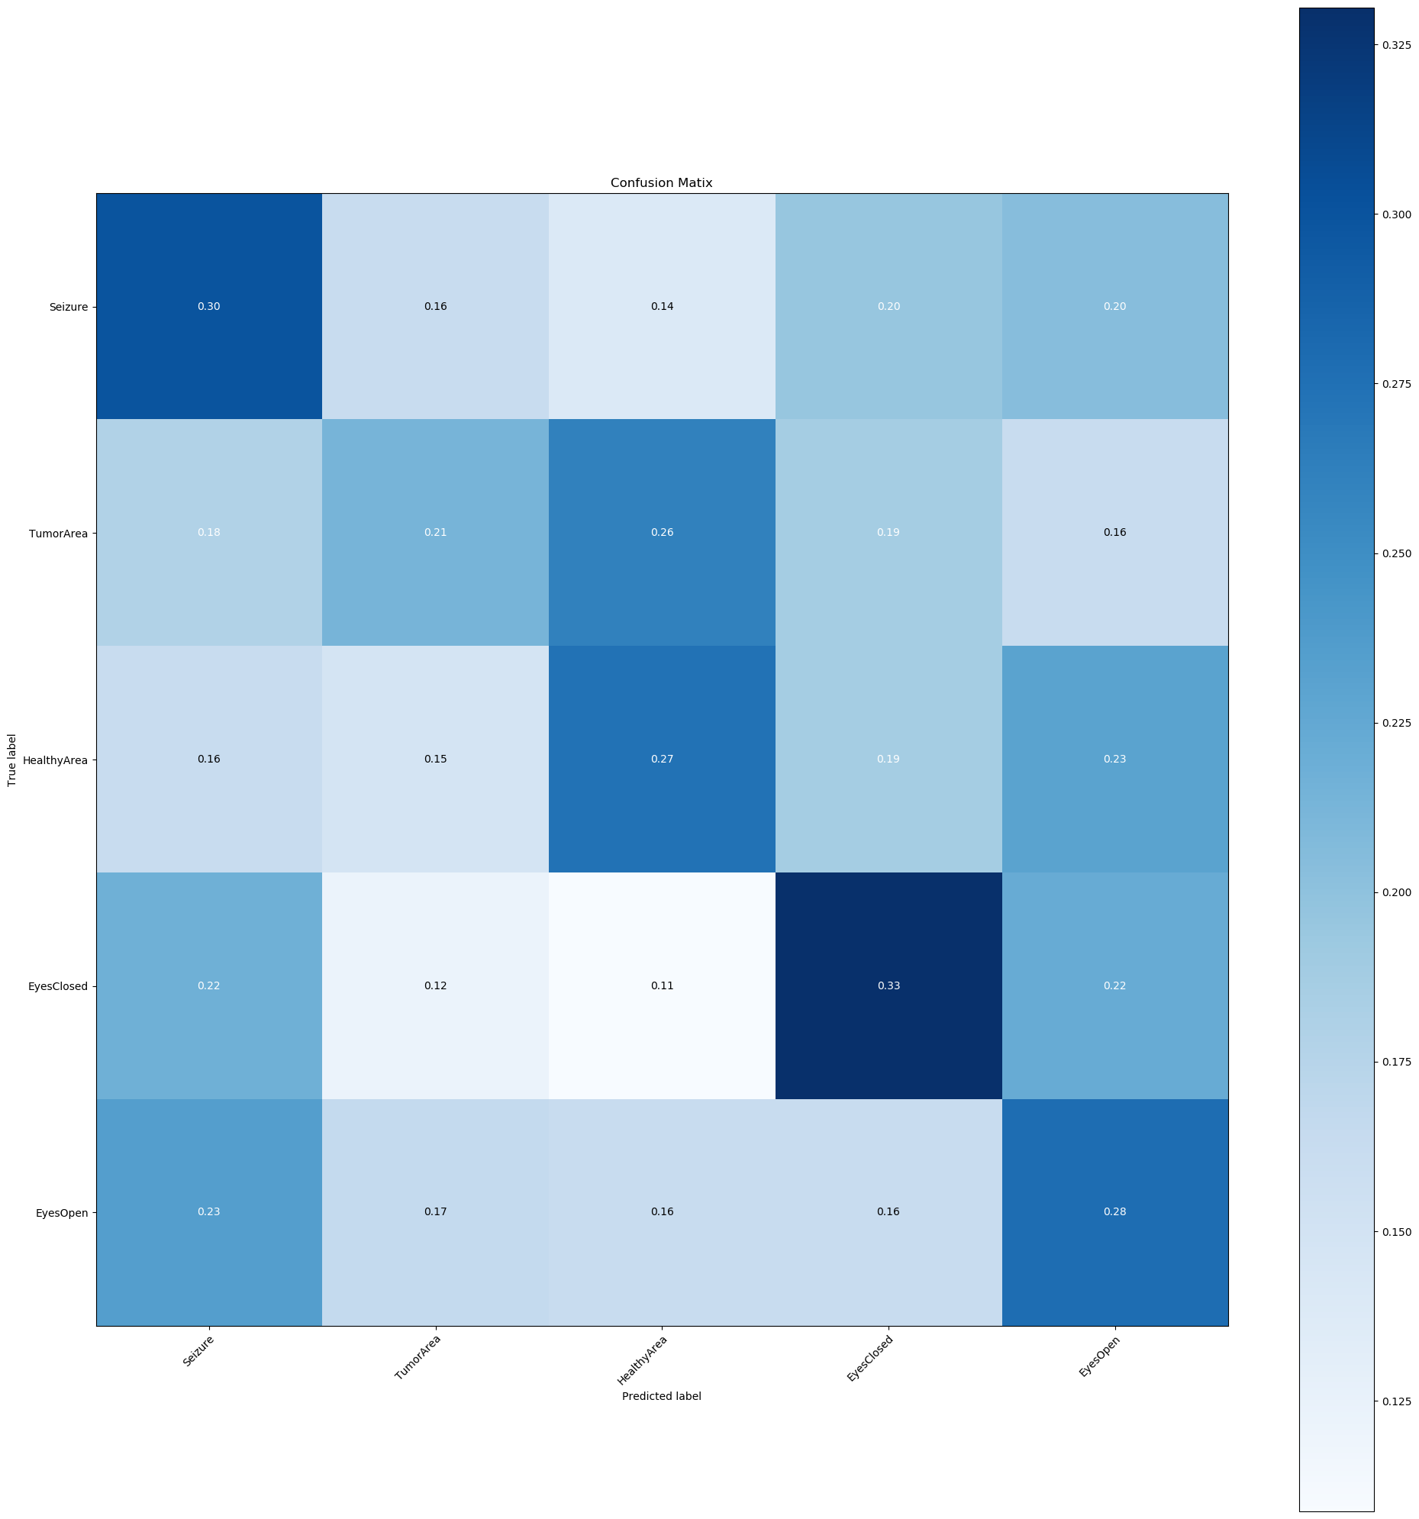
Illustration 2: MLP Confusion Matrix

Q1.2e

Architecture
- Hidden Layer 1 – 178 Inputs | 100 Outputs | ReLu Activation
- Hidden Layer 2 – 100 Inputs | 50 Outputs | ReLu Activation
- Hidden Layer 3 – 50 Inputs | 24 Outputs | ReLu Activation
- Hidden Layer 4 – 24 Inputs | 12 Outputs | Sigmoid Activation
- Output Layer – 12 Inputs | 5 Outputs | Logits

This architecture was chosen because the original model suffered from high bias. It wasn’t capable of generalizing to the training data nor the validation data. That is because the model stepped down too quickly in dimensionality 178 → 16 → 5. This didn’t allow the model to learn anything about the data. To counteract this, 3 extra hidden layers were added to control the descent in dimensionality. ReLU activation was utilized in the inner 3 hidden layers with sigmoid activation being utilized for the last hidden layer. ReLU was used in earlier layers to prevent any vanishing gradient problem during back propagation. Since the output of a sigmoid is 0 or 1, during training, one risks mulitplying a small number via a small number. This as a consequence would result in an even smaller number, forcing the gradients to “vanish”. The result of this model is >90% training accuracy and >70% validation accuracy. The model is suffering, now, from high variance [over fitting], which could be counteracted via regularization.
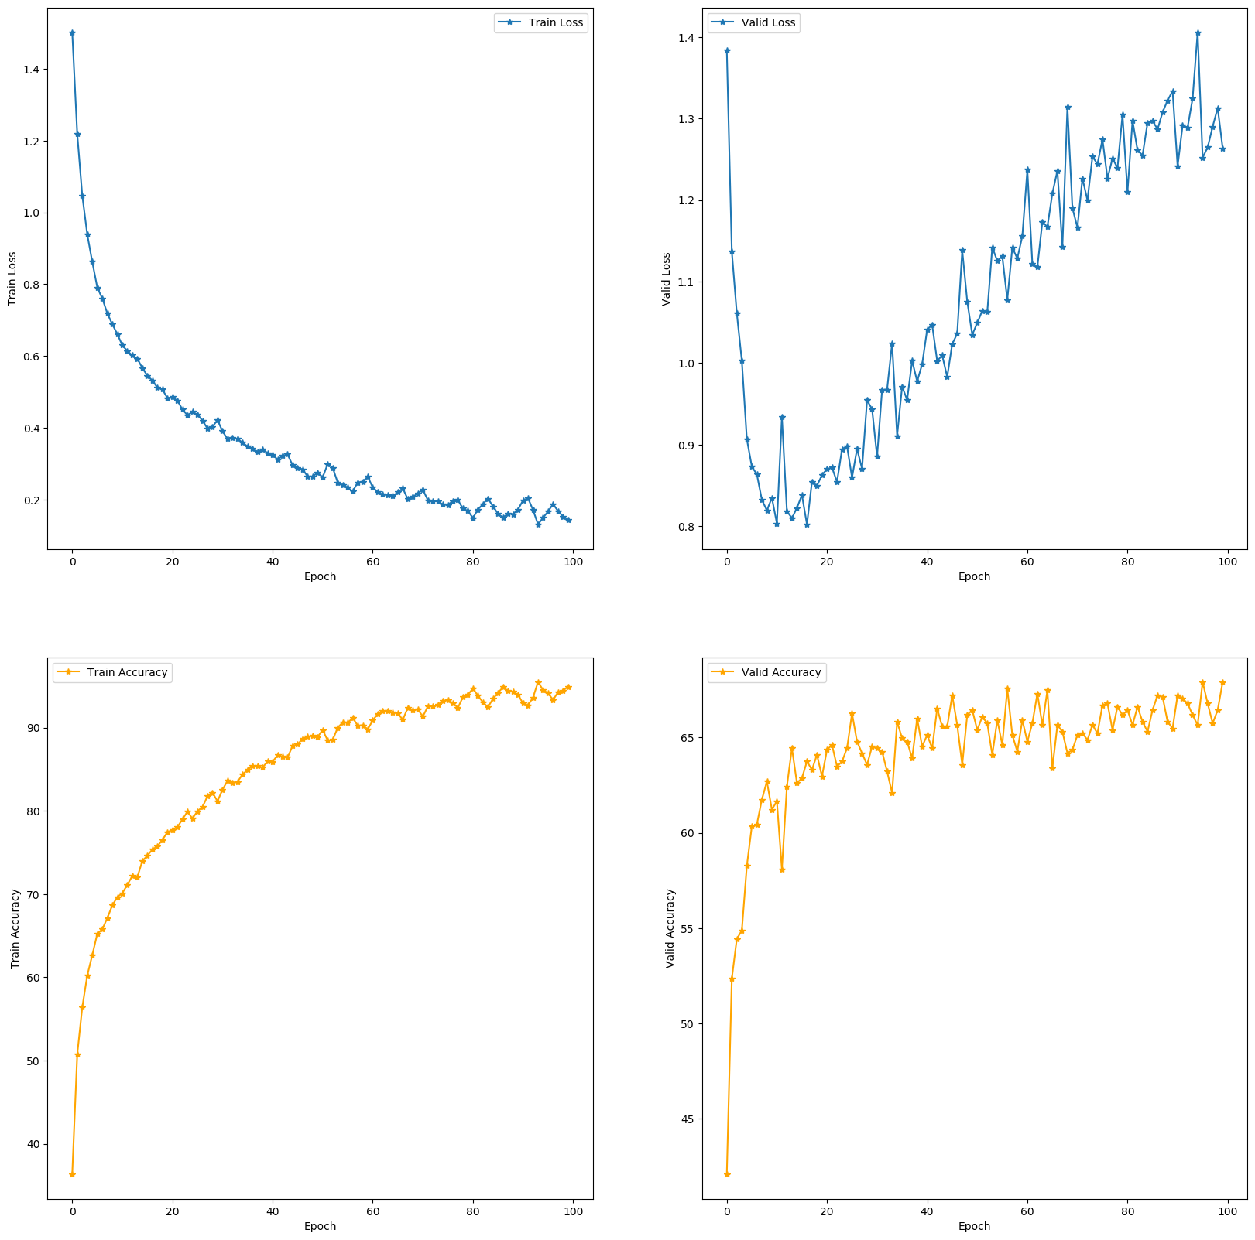Illustration 3: (Upper Left) Training Loss; (Upper Right) Validation Loss; (Lower Left) Training Accuracy; (Lower Right) Validation Accuracy

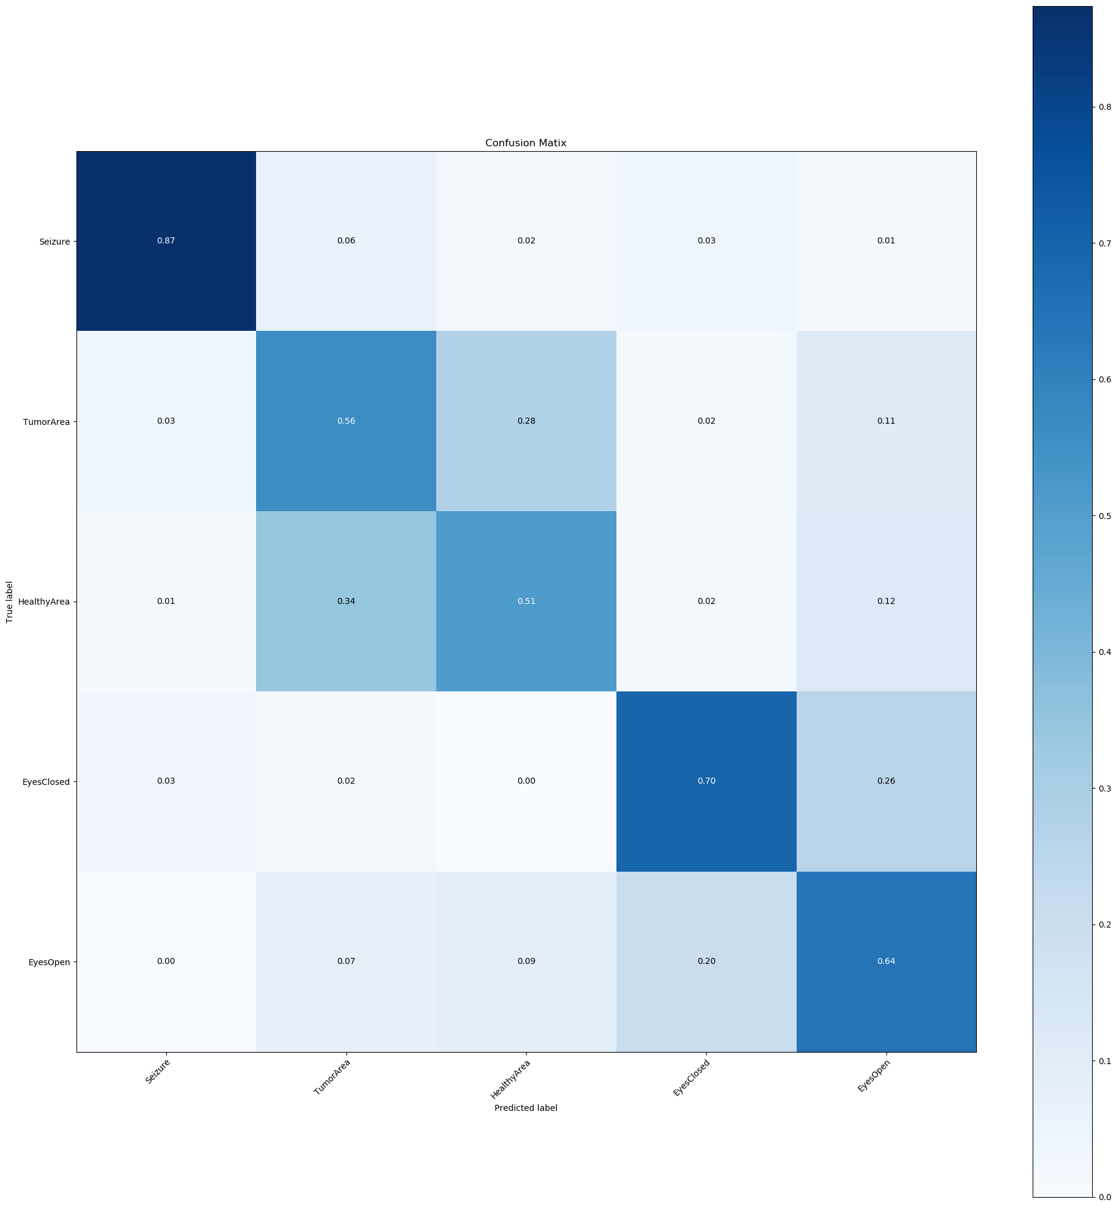Illustration 4: Custom MLP Confusion Matrix

Q1.3b
Conv1 → 5x1 filter | Stride 1 | 6 outputs
* 6 – (5x1) filters learned = ((5x1 + 1) * 6) = 36

Conv2 → 5x1 filter | Stride 1 | 16 outputs
* 16 – (6x5x1) filters learned = ((6x5x1 + 1) * 16) = 496

Fc1 → 128 neurons plus bias term | Flattened Output from previous layer = 16 * 41 = 656
* (128 x 656) + 128 = 84096

Fc2 → 5 neurons plus bias term | 128 Input features
* (128 x 5) + 5 = 645

Total Trainable Parameters = 85,273

FLOPs
Conv1 → 1 convolution sample = 5 multiplications & 5 addition ops
Conv1 Stride → stride of 1 = convolve sample 178 – (length of filter (5)- 1) = 174 times
Conv Ops 6 filters →(5 + 5) * 174 * 6 = 10,440
Conv1 Activation relu = 1 comparison op for 6 filters = 10,440 + 6 = 10,446
Pool1 → Stride 2 | size 2 = (174 /2) = 87 comparison ops * 6 filters = 522
Conv1 Block FLOPS = 522 + 10,446 = 10,968

Conv2 → 1 convolution sample = 5 multiplications & 5 addition ops
Conv1 Stride → stride of 1 = convolve sample 87 – (length of filter (5)- 1) = 83 times
Conv Ops 16 filters →(5 + 5) * 83 * 16 = 13,280
Conv2 Activation relu = 1 comparison op for 16 filters = 13,280 + 16 = 13,296
Pool2 → Stride 2 | size 2 = floor(83 /2) = 41 comparison ops * 16 filters = 656
Conv2 Block FLOPs = 656 + 13296 = 13952FC1 – 128 neurons x 656 inputs = 83968 multiplication ops & 83968 addition ops = 167936
FC1 activation relu = 128 comparison ops
FC1 FLOPs = 128 + 167936 = 168064

FC2 – 5 neurons x 128 inputs = 640 multiplication ops & 640 addition ops = 1280
FC2 no activation
FC2 FLOPs = 1280

Total FLOPs = 10968 + 13952 + 168064 + 1280 = 194264 per observation

Q1.3c
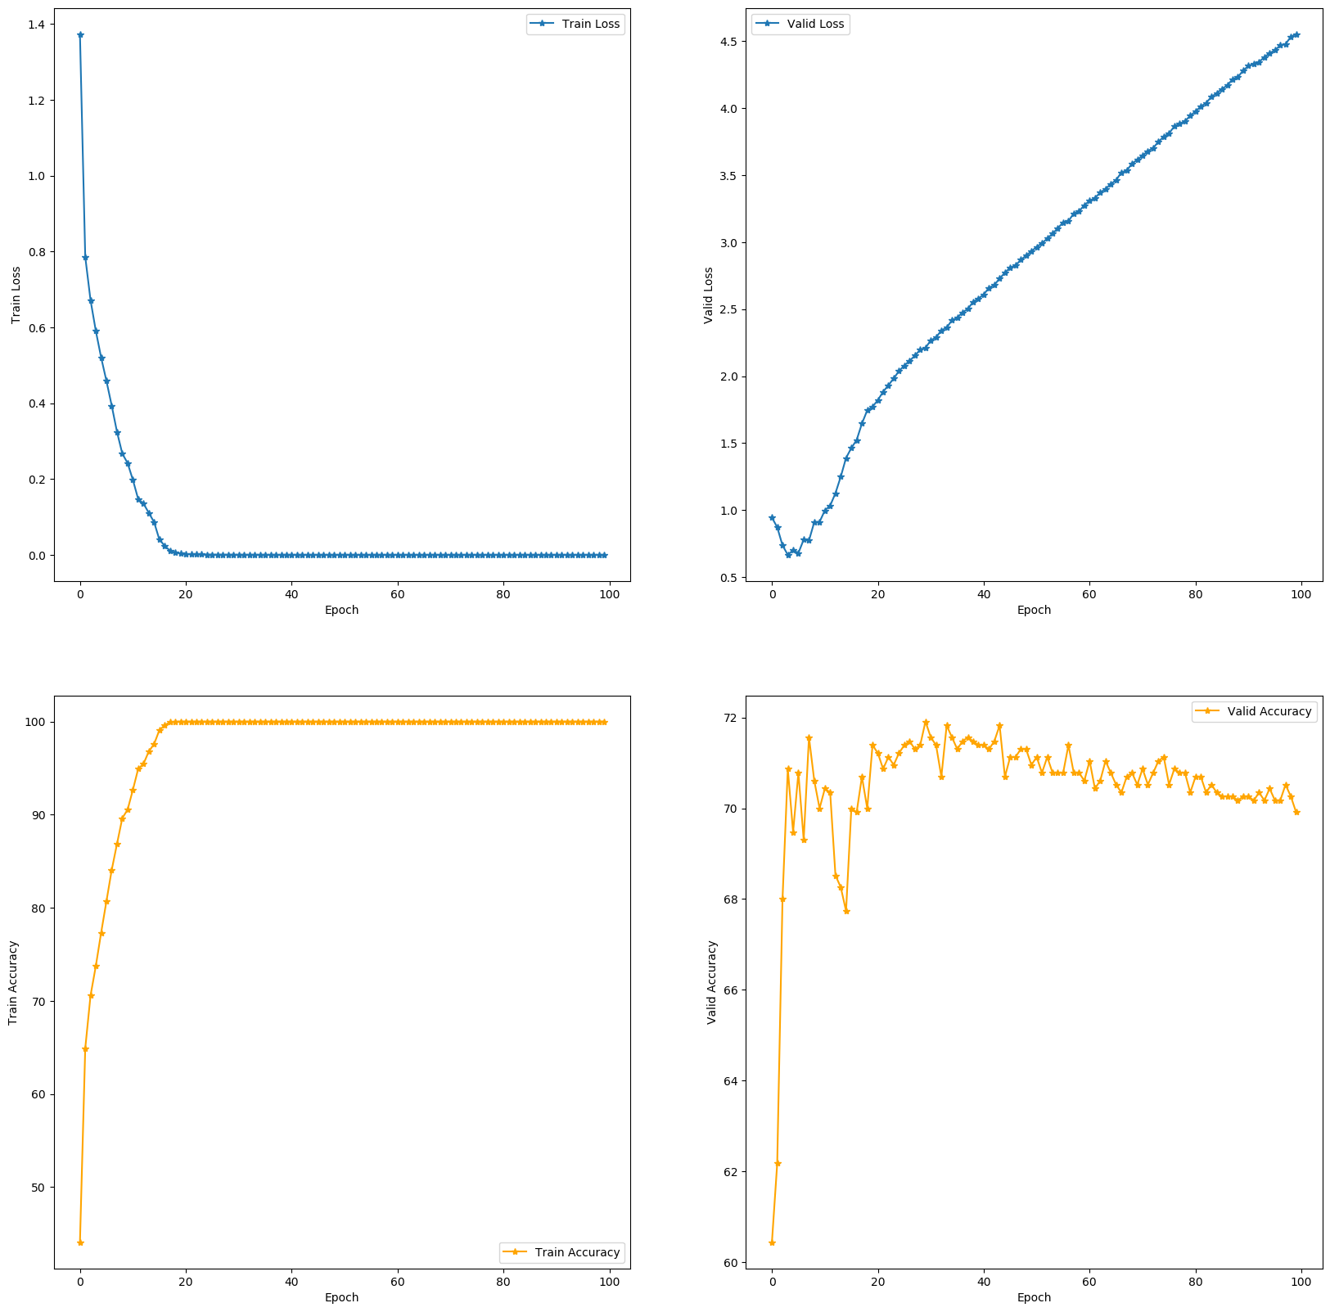Illustration 5: (Upper Left) Training Loss; (Upper Right) Validation Loss; (Lower Left) Training Accuracy; (Lower Right) Validation Accuracy

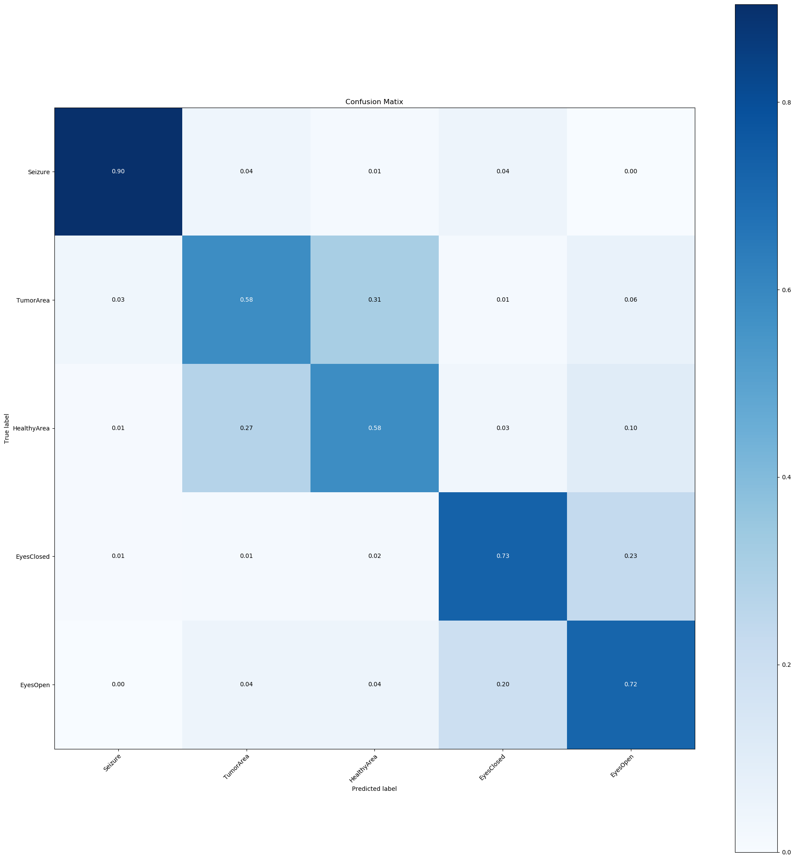Illustration 6: CNN Confusion Matrix

Q1.3d
The original CNN Architecture suffered from the same issue as the MLP, it dropped in dimensionality too quickly all the while growing the parameters abruptly. A successful CNN follows the trend of monotonically reducing output dimension while monotonically increasing number of parameters with each Convolutional block. To mimic this, 5 convolutional blocks were instituted and the kernel size was reduced from 5 to 3. With each output for a convolutional block, the output dimension is decreasing, but the number of parameters are increasing via number of filters (out channels) per each block. This resulted in better precision and recall.

Each conv block used relu activation and max pooling
ConvBlock1(3, 3) → ConvBlock2(15, 3) → ConvBlock3(20, 3) → ConvBlock4(30, 3) → ConvBlock5(100, 3)

Where the first number is the number of filters for that ConvBlock and the second number is the kernel_size
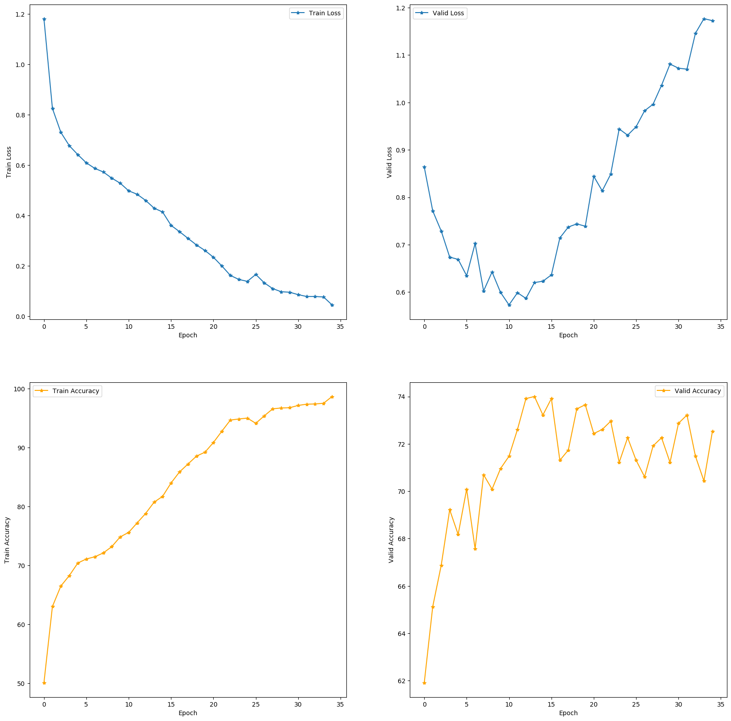Illustration 3: (Upper Left) Training Loss; (Upper Right) Validation Loss; (Lower Left) Training Accuracy; (Lower Right) Validation Accuracy
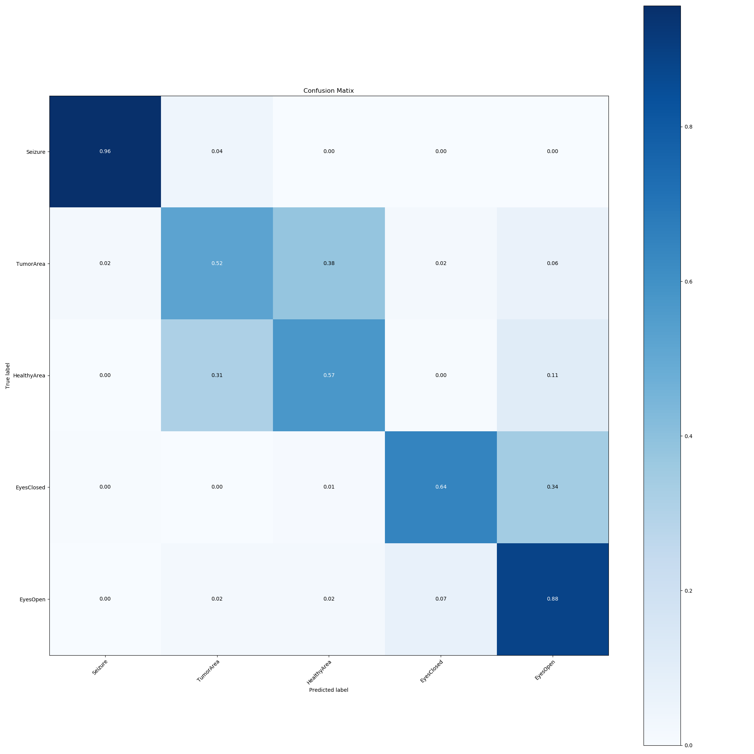

Q1.4b
GRU cell → 16 Hidden units | 178 inputs | 3 Feed Forward Neural Networks in a Cell
GRU cell params = #of NNs * (#ofHidden units (#ofHidden units + 1) + #ofHidden units)
1 GRU cell = 3 * ( 16 (16 + 178) + 16) = 9,360
2 GRU cells = 2 * 9360 = 18720

FC1 → 5 Neurons | 32 Inputs | plus bias
FC1 params = (5 * 32) + 5 = 165

Total Trainable Parameters = 165 + 18720 = 18885

FLOPs
A FC in the first GRU has 16 neurons and 178 inputs and tanh activation = (e^z – e^-z) / (e^z + e^-z) or 7 FLOPs and sigmoid activation or 3 FLOPs
FC = 16 neurons * (178 multiplication ops + 178 addition ops) = 5696
3sigmoid + 5696 FC input + 5696 FC hidden state = 11395

3sigmoid + 5696 FC input + 5696 FC hidden state = 11395

7tanh + 5696 FC input + 5696 FC hidden state = 11399

4 * 16 = 64
FLOPS GRU CELL 1 = 34253

A FC in the second GRU has 16 neurons and 16 inputs
FC = 16neurons * (16 multiplication ops + 16 addition ops) = 512
rt = 3sigmoid + 512 FC input + 512 FC hidden state = 1027
zt = 3sigmoid + 512 FC input + 512 FC hidden state = 1027
nt = 7sigmoid + 512 FC input + 512 FC hidden state = 1031
ht = 4 * 16 = 64
FLOPS GRU CELL 2 = 3149

Final FC layer has 5 neurons with 32 inputs and 5 bias
FC = (5 * 32) + 5 = 165

TOTAL FLOPs = 37567

Q1.4c

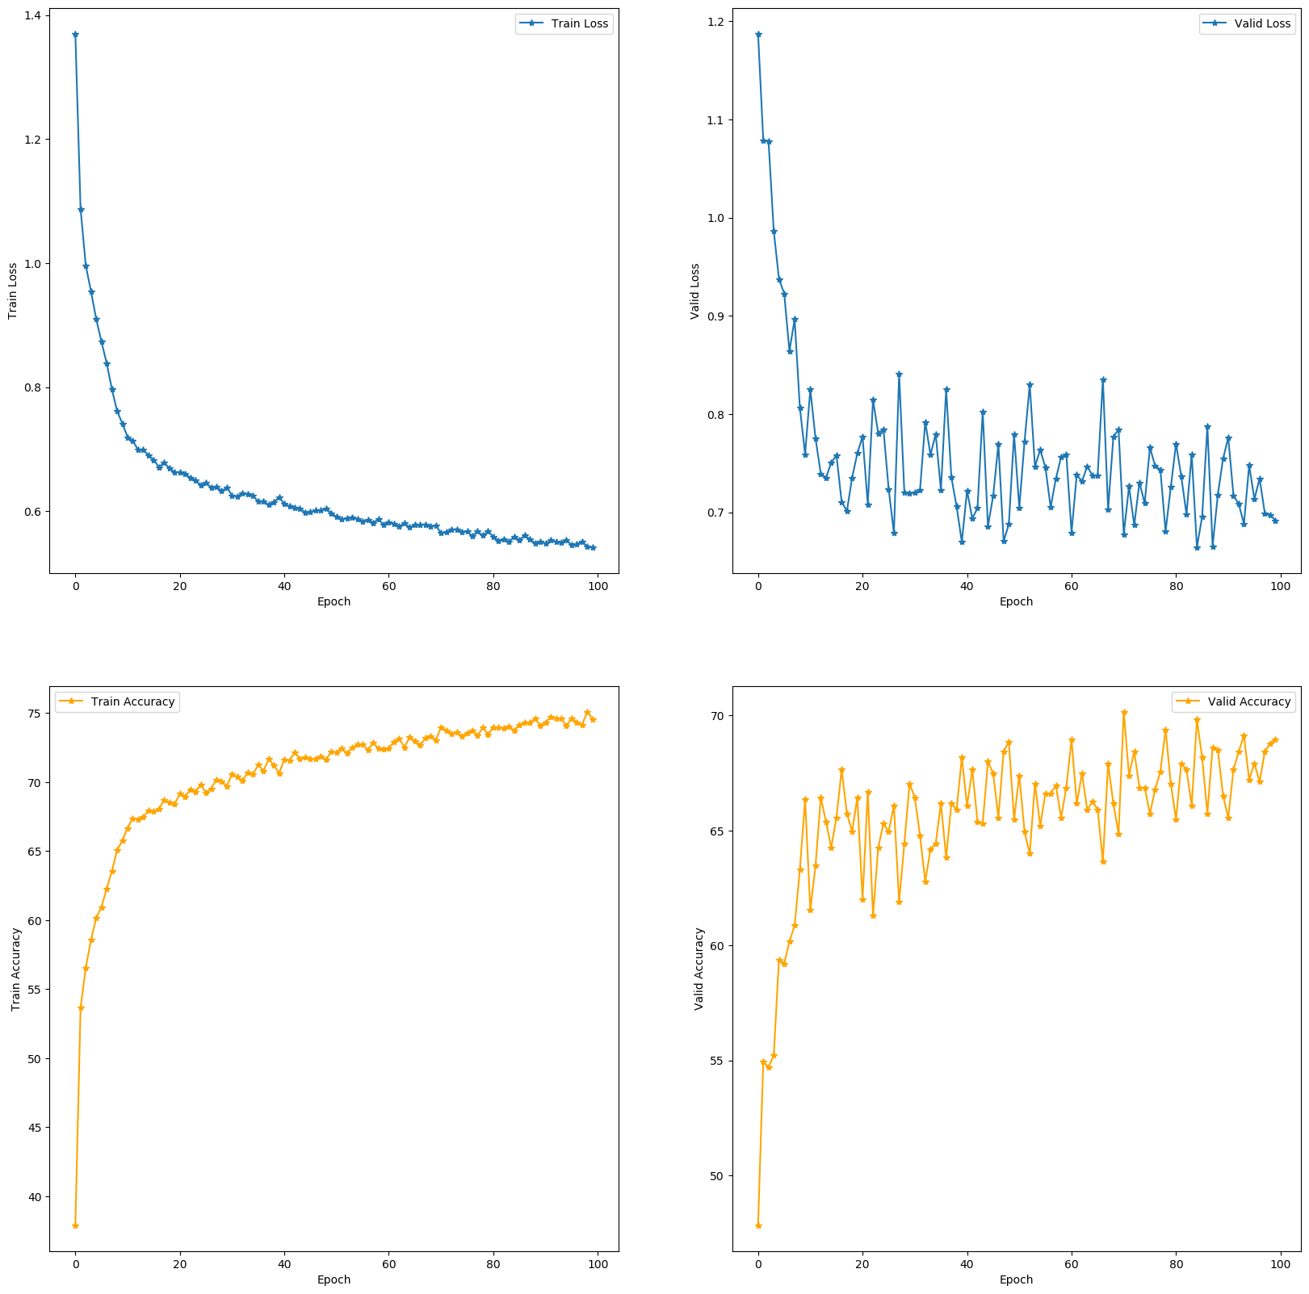Illustration 4: (Upper Left) Training Loss; (Upper Right) Validation Loss; (Lower Left) Training Accuracy; (Lower Right) Validation Accuracy
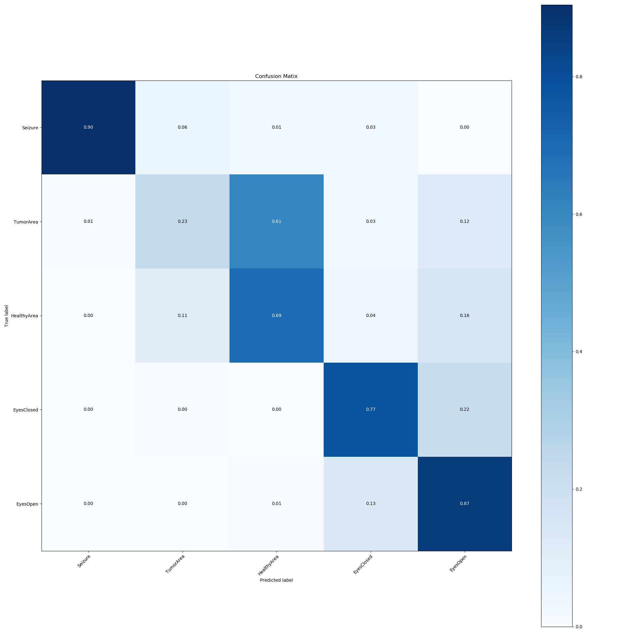Illustration 5: RNN Confusion Matrix

Q1.4d
The original RNN architecture plateaued at around 70% validation accuracy while the train accuracy was only around 75%. This is a sign of potential high bias. To combat this, more layers were added in the GRU in attempts to get the model to learn more complex features. By adding only 2 more GRU layers and stepping down the feature dimension space, the model’s train accuracy reached ~80% while the the validation accuracy increased to ~75%. This indicates that more layers would be beneficial, but due to extremely long train times, more layers weren’t attempted
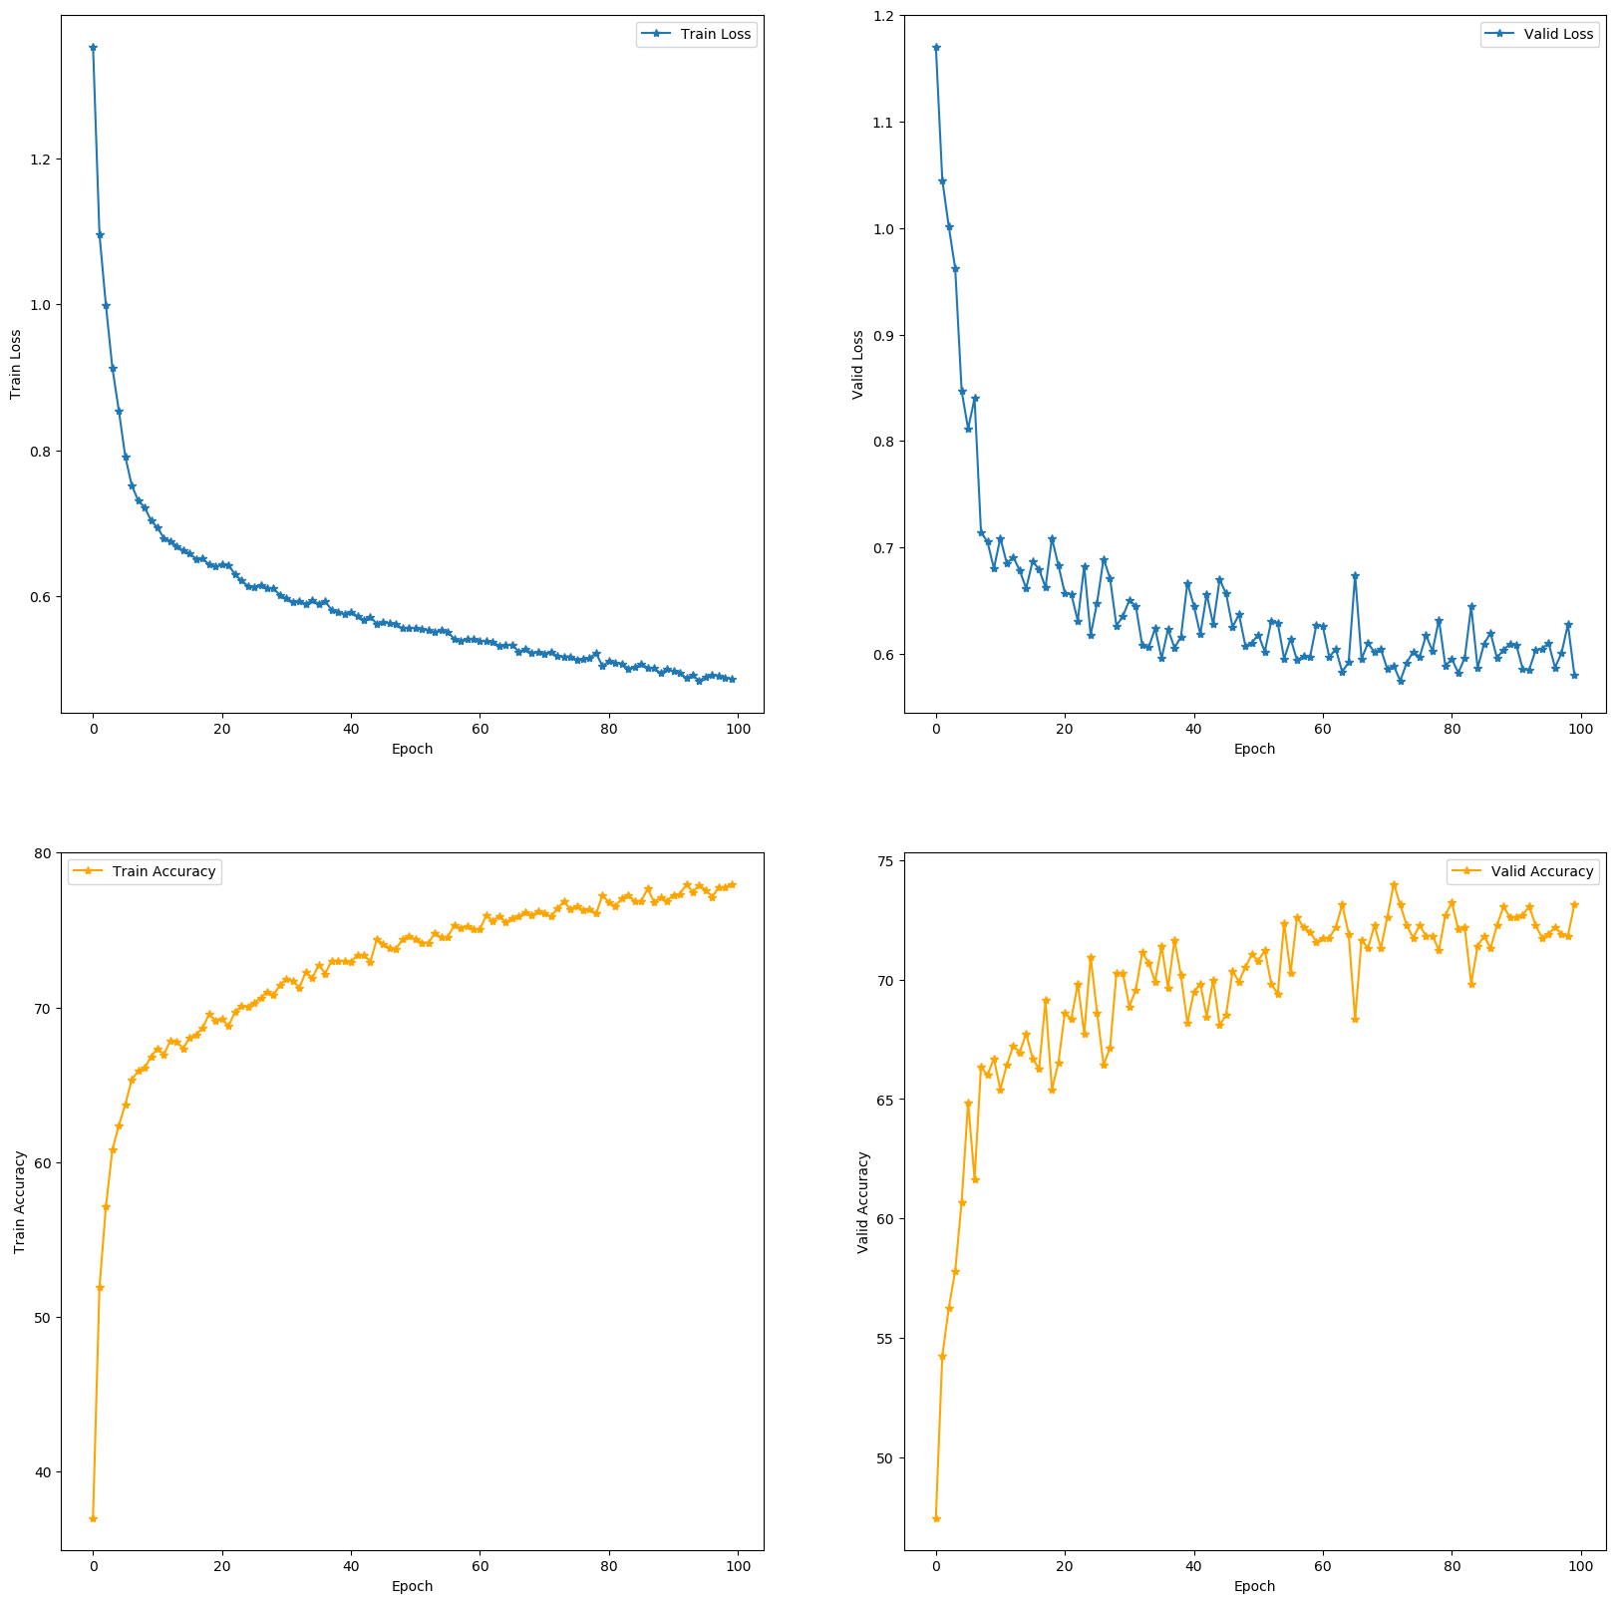Illustration 6: (Upper Left) Training Loss; (Upper Right) Validation Loss; (Lower Left) Training Accuracy; (Lower Right) Validation Accuracy

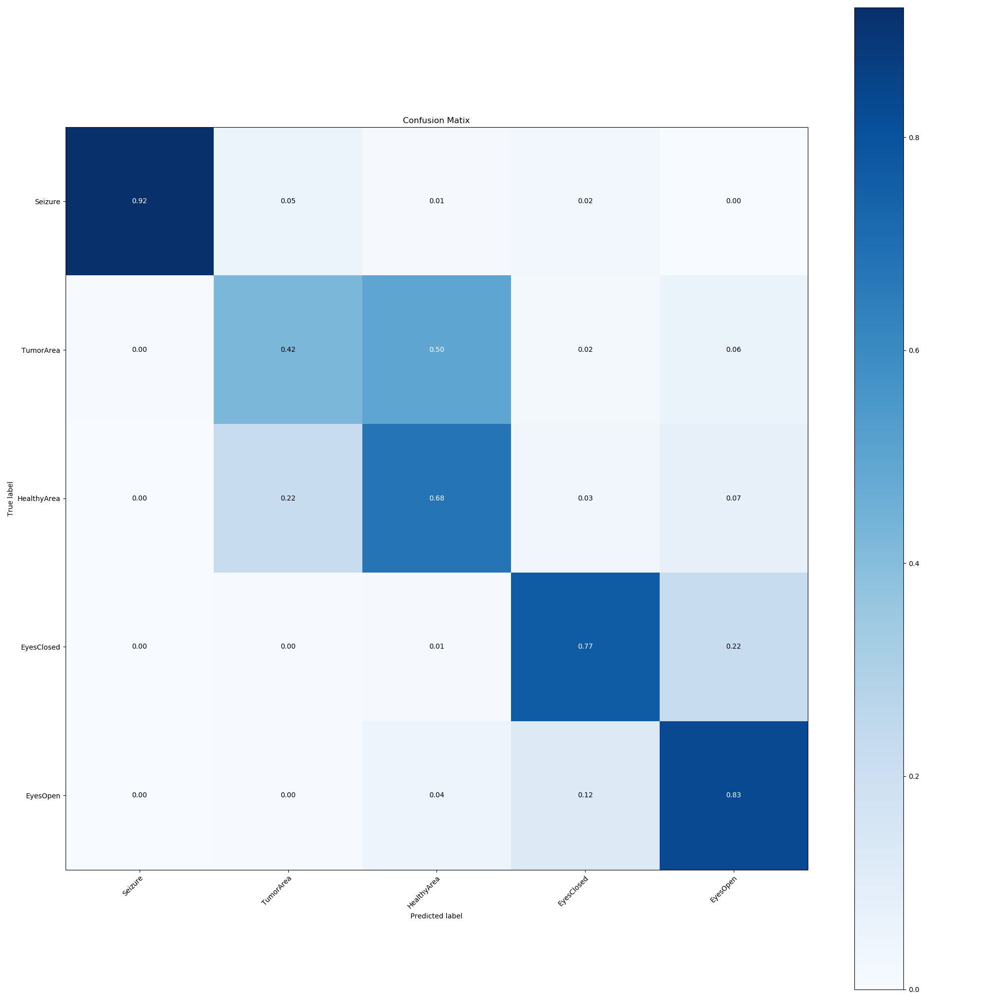Illustration 7: Custom RNN Confusion Matrix

Q2.3a
From the training statistics (Train vs Validation), it is evident the model is suffering from high variance. It is drastically overfitting itself to the random patterns embedded in the training set. It is highlighted in the graphs below around Epoch 10, Training loss drops off drastically while accuracy increases sharply. In contrast to this, around the same epoch, the validation set experiences an increase in velocity of large losses while the accuracy drops tremendously
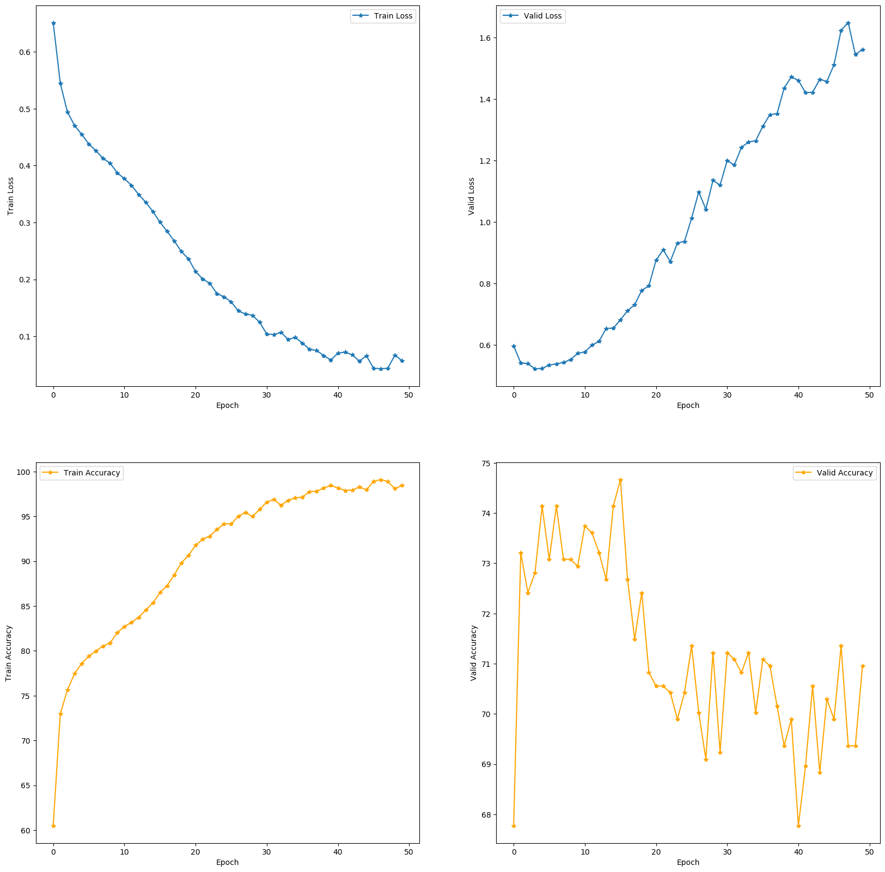Illustration 8: (Upper Left) Training Loss; (Upper Right) Validation Loss; (Lower Left) Training Accuracy; (Lower Right) Validation Accuracy
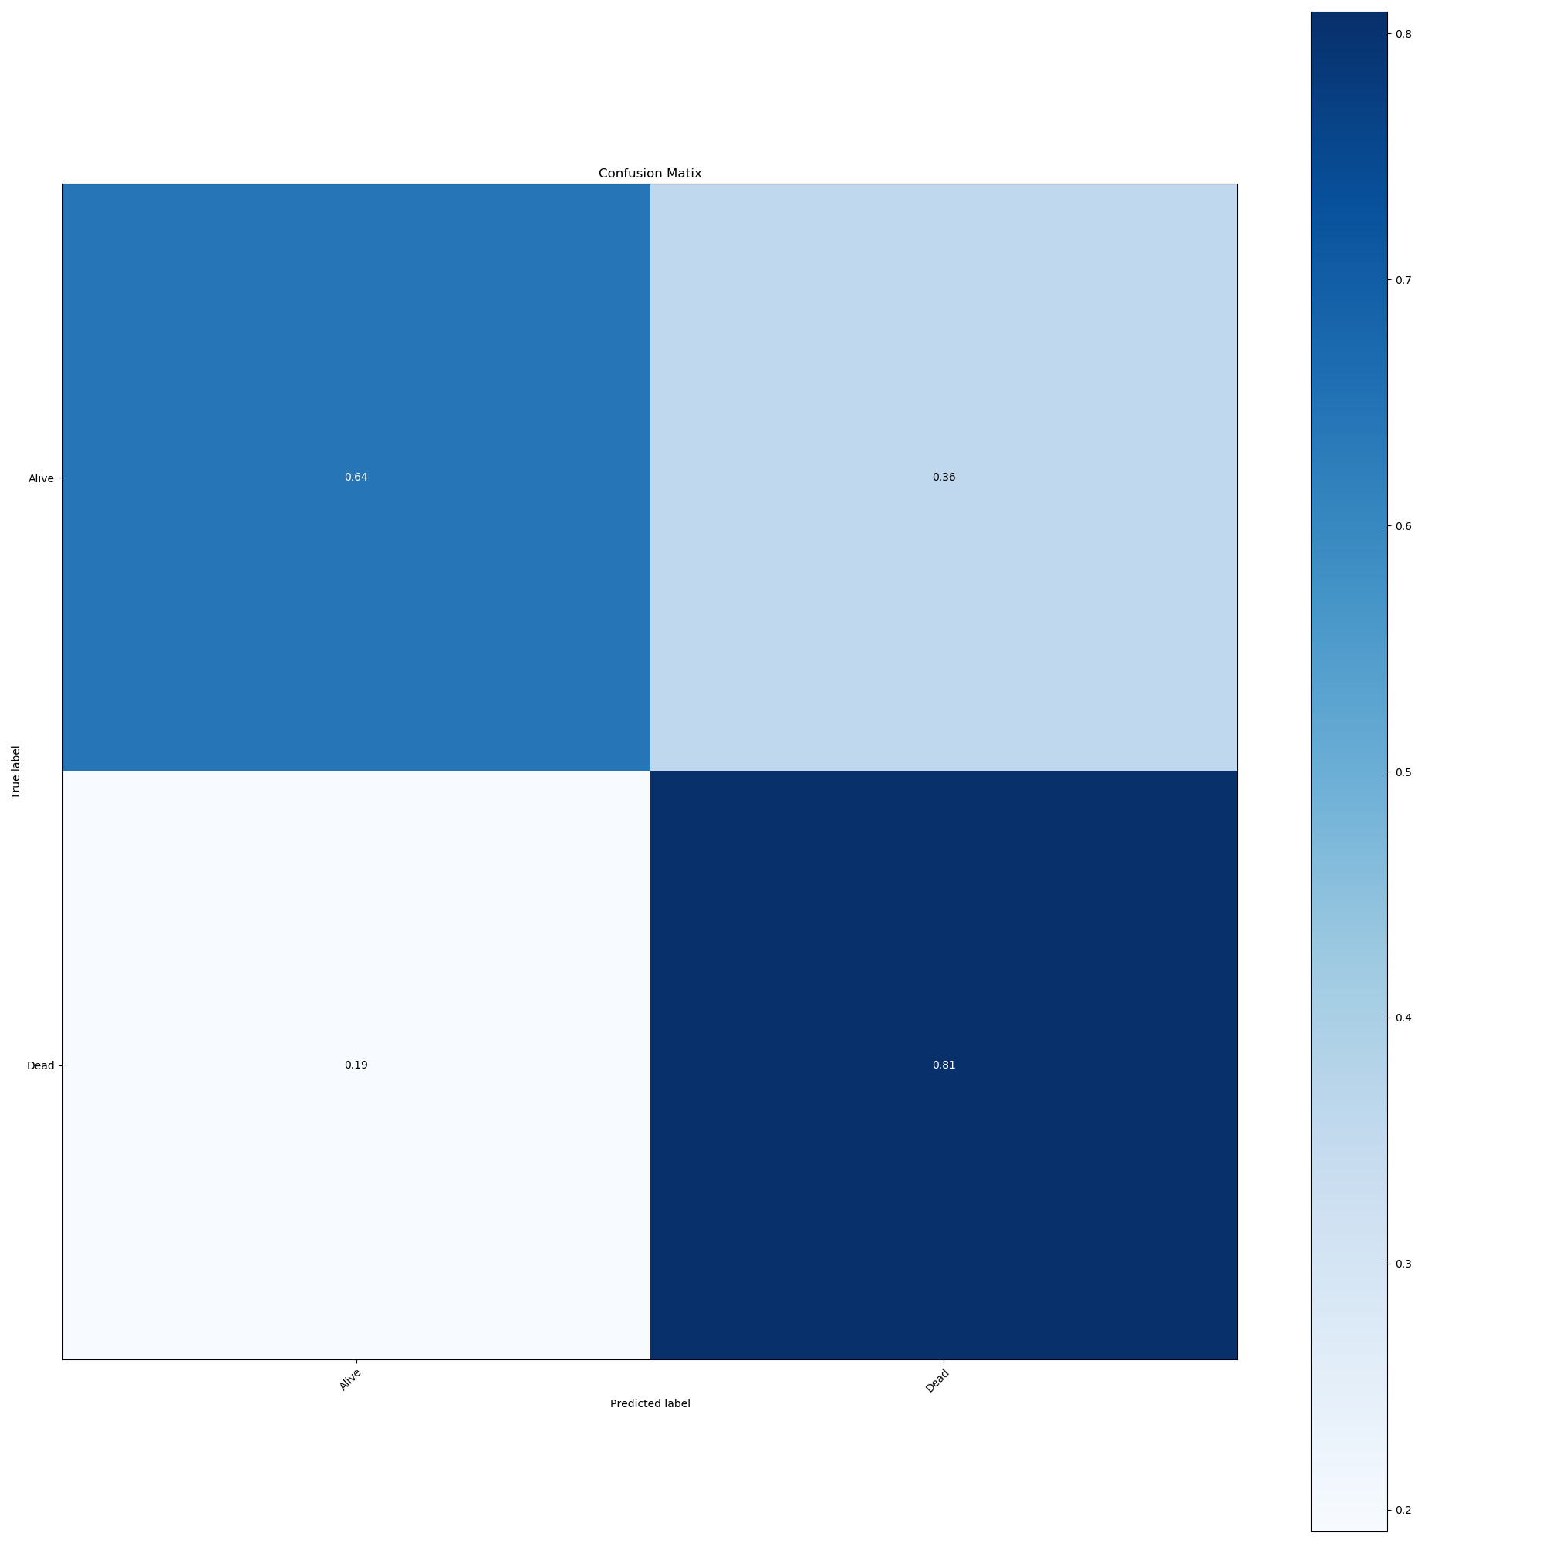Illustration 9: Variable RNN Confusion Matrix

Q2.3b
For this architecture, I added more Fully connected layers before the GRU. I instituted LeakyReLU activation to attenuate the risks of vanishing gradients as well as dropout layers to prevent overfitting. Each layer reduces the tensors in dimension, gradually stepping down output. 4 GRU layers were added in hopes to increase the model’s capability of “remembering” important features. Ultimately, this model does perform better than the original architecture, but does suffer from high variance (overfitting). This can be seen in the graphs below where 100% accuracy has been achieved with the training set, but the validation set has plateaued between 71-73%. The model also does a better than decent job at being predicting “dead”, but only a little better than guessing with respect to predicting “alive”
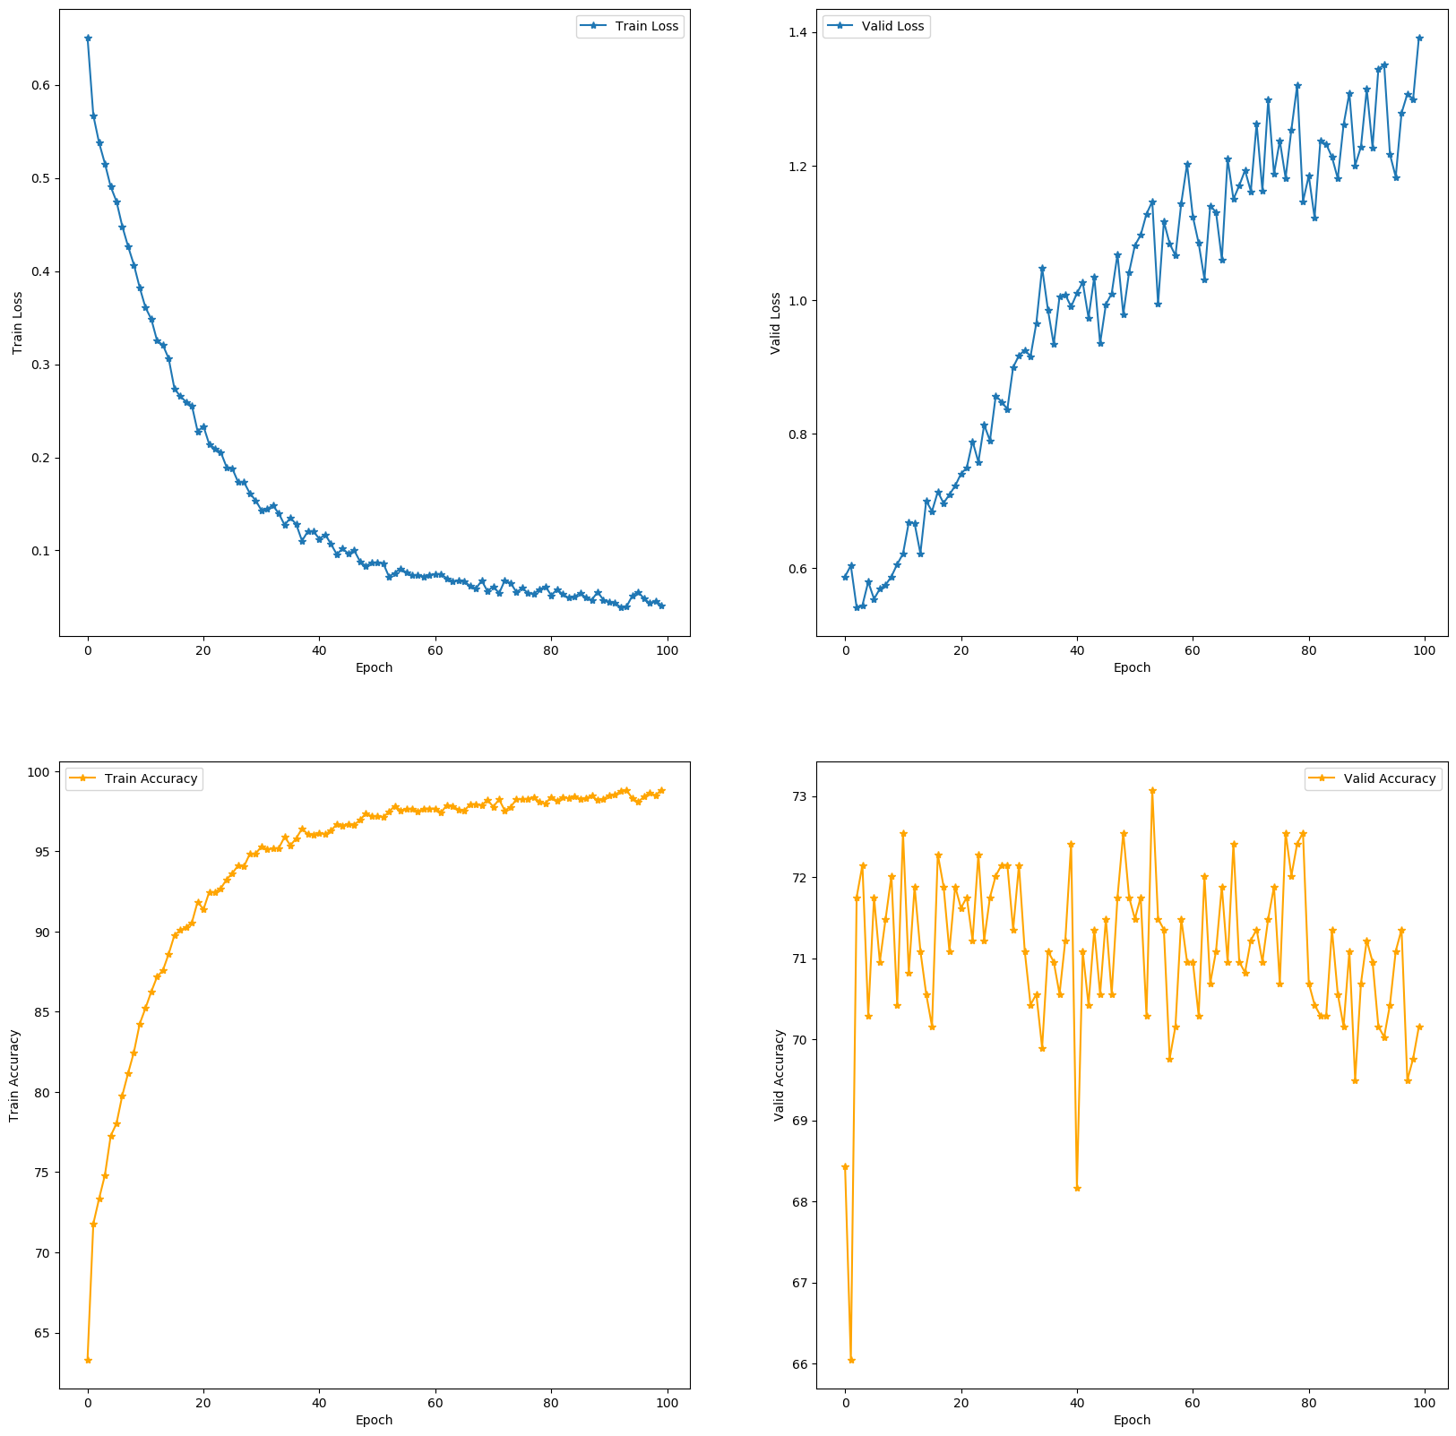Illustration 10: (Upper Left) Training Loss; (Upper Right) Validation Loss; (Lower Left) Training Accuracy; (Lower Right) Validation Accuracy

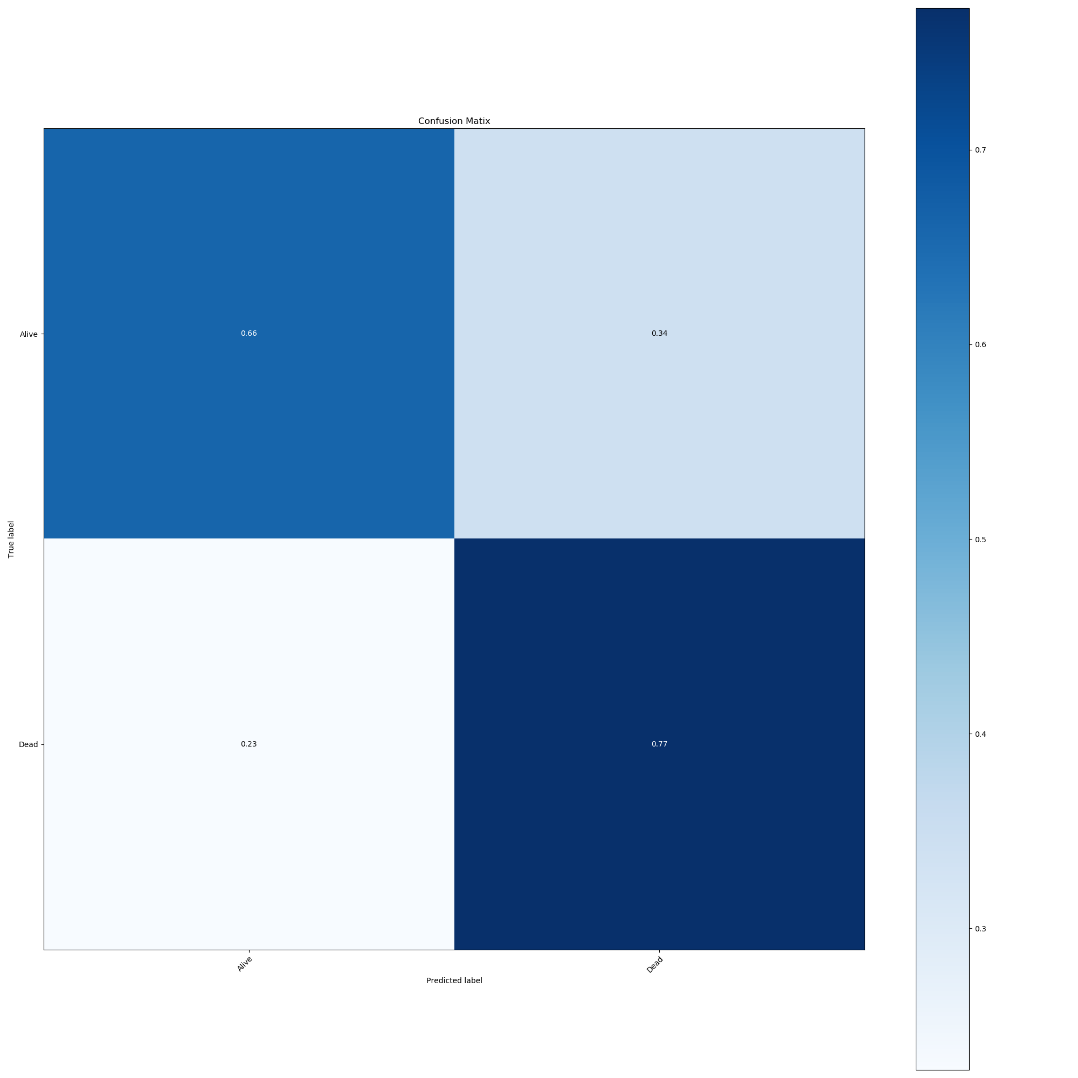Illustration 11: Custom Variable RNN Confusion Matrix

